PROJECT REPORT

on

"Charity App"

By

Dhanvi Mange- 119A3013

Divyalaxmi Thiruganan- 119A3015

Mahitha Vaidyanathan- 119A3054

Sai Pavani Lanka- 119A3056

UNDER THE GUIDANCE OF

**Prof. Masooda Modak**

SUBMITTED IN PARTIAL FULFILLMENT FOR THE DEGREE OF

BACHELOR OF ENGINEERING

In

Information Technology



**DEPARTMENT OF INFORMATION TECHNOLOGY**

**SIES GRADUATE SCHOOL OF TECHNOLOGY**

**NERUL, NAVI MUMBAI – 400706**

ACADEMIC YEAR

2020– 2021

**CONTENTS**

|  |  |  |
| --- | --- | --- |
| Sr.No. | Topic | Page No. |
| I | Abstract | 3 |
| II | List of Tables or Figures if any | 4 |
| 1. | w Introduction | 5 |
| 1.1 | Motivation | 5 |
| 1.2 | Problem Statement & Objectives | 5 |
| 2. | Literature Survey | 6 |
| 2.1 | Survey of existing System | 6 |
| 2.2 | Limitation Existing System or Research Gap | 6 |
| 3 | Proposed System | 7 |
| 3.1 | Introduction | 7 |
| 3.2 | Architecture /Framework | 8 |
| 3.3 | Process design | 8 |
| 3.4 | Details of hardware and software | 9 |
| 3.5 | Experiment Results | 10 |
| 4 | Future Scope | 28 |
| 5 | Conclusion | 29 |
| 6 | References | 30 |

**ABSTRACT**

The project is about designing an online donation management system to enable every person/household to donate anything easily. As many charity organisations are making a big effort to collect donations. It is quite costly and inefficient for charity organisations to do on-door envelope distribution and collection. While many people have unwanted things at their homes, they couldn’t donate due to time limitations. The basic idea is to help people to select preferred charity organisations and send the donation information online to inform charity organisations. Also to help charity organisations to provide better management of their resources and only make necessary door to door collections.

**LIST OF FIGURES**

|  |  |  |
| --- | --- | --- |
| **Figure No** | **Figure Caption** | **Page No** |
| **1** | **Welcome Page** | **13** |
| **2** | **Register Page** | **14** |
| **3** | **Login Page** | **15** |
| **4** | **Displaying Campaign** | **16** |
| **5** | **My Donations Page before making a Donation** | **17** |
| **6** | **Selecting Clothes Category for Donation** | **18** |
| **7.1** | **Displaying Campaign Details** | **19** |
| **7.2** | **Displaying Campaign Details** | **20** |
| **8** | **Entering Quantity for Donation** | **21** |
| **9** | **Confirming Donation** | **22** |
| **10** | **My Donation Screen after Donation** | **23** |
| **11** | **NavBar** | **24** |
| **12.1** | **About Us Screen** | **25** |
| **12.2** | **About Us Screen** | **26** |
| **12.3** | **About Us Screen** | **27** |
| **13** | **Contact Us Screen** | **28** |
| **14.1** | **Updated Database** | **29** |
| **14.2** | **Updated Database** | **29** |
| **14.3** | **Updated Database** | **29** |

**INTRODUCTION**

**Motivation**

Today, you can find an app for nearly everything, including fundraising. With smartphones reaching near-ubiquity in most parts of the world, charities, nonprofits, and non-governmental organisations are pushing their money-raising campaigns to mobile devices through fundraising apps, responsive website designs, and text-to-give programs. Our goal is to convince a millennial generation to donate more consistently online to further develop sustainable programs. We hope to diversify donor base by making the app more appealing to a younger audience, seeking to employ more of a “micro donation”. We aim to collect small & common household goods, making it easier for donors who are incapable of donating money.

**Problem statement**

1. Earlier, if an NGO held campaigns, they would have to go door-to-door asking for donations, we aim to eradicate that problem with the help of our app.
2. The users did not have a platform to donate common household items as most existing systems focus on the collection of money for charities.
3. A large amount of waste of individual household food and various other items are avoidable, especially in developed countries. Therefore, we want to explore ways to encourage donations of household items from individual households.

**Objective:**

The objectives behind this project are as follows: -

1. Through this app we are creating a link between the charities and donors.
2. Help charities (large or small) to gain more donations.
3. Reduce door to door collections.
4. To make the process more efficient and less time consuming and easier to access.

**LITERATURE SURVEY**

Literature Survey based on various sources: -

|  |  |  |
| --- | --- | --- |
| **Sr. No** | **Author** | **Key findings/Gap** |
| 1 | Dunn, Aknin, & Norton: | Spending on others increases happiness more than spending on oneself. |
| 2 | Liu & Aaker | Nudging solicitation from amount of money to amount of time increases giving counts. |

**Limiting Existing system or Research Gap**

The limitations of existing system are:

1. Most Existing systems focus on monetary collection from donors.
2. The Existing Systems do not allow the donation of common household products.
3. We provide the facility to pick up the donation from the donors and deliver it to the NGOs, which is not an option in Existing Systems.

**PROPOSED SYSTEM**

**Introduction**

Every human being wants to be a part of the development of the society, nature and contribute to any cause. This charity app brings users towards fulfilment of that purpose. This application is fully categorized with all types of charitable acts i.e., animal charity, food charity, women charity, clothes charity, etc. Users who donate to charity can get all information regarding specific charity type. It provides an overview of various charity aid foundations. The users of this charity app may also view the donations made by them.

This app aims to help users with their charitable donations by giving them a platform where they can find trustworthy charities and easily donate household goods to them. Charity is a universal act that has been a part of our society for thousands of years.

**Process Desgin**

The details for the proposed system are as follows:

1. The user will have to register into our interface by providing their email-ids
2. On logging in the user will be displayed the various Categories to which they can donate. For example, Women, Education, Clothes, Animal, etc
3. On selecting one of the Categories, the user will be redirected to a page where the various on-going campaigns will be displayed with some brief details about the campaign.
4. If the user wishes to know more about the campaign or donate towards the cause, they may click on the campaign card. After which they will be redirected to the screen where they will find the products they can donate to the campaign.
5. On clicking the donate button, a confirm donation page would be displayed. The user has to input their personal details and confirm the donation.
6. One of the volunteers would come and pick up the donations on the specified date.
7. To view the donations made by the user, they may click on the ‘My Donations’ tab from the Navigation Bar on the left-hand corner of the screen.
8. The interface is a user-friendly tool which helps the user to connect with various campaigns and donate common household products towards them.

**System Architecture**

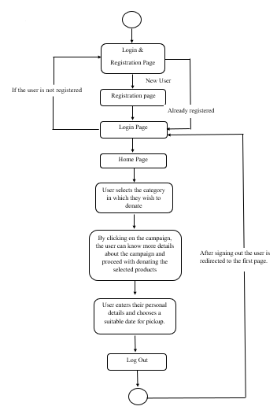

**Details of Hardware and Software**

Software Requirements for the project are as follows:

1. Operating System: Windows 10.
2. Programming Languages: Flutter & Firebase
3. IDE: PyCharm.
4. Web Browser: Google Chrome.

**EXPERIMENT RESULTS**

Fig 1 Welcome Page

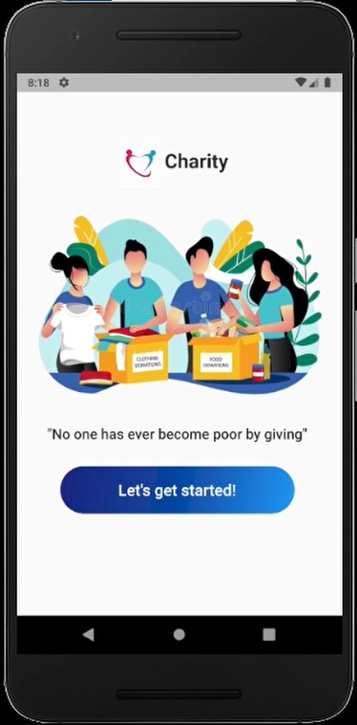

Fig 2 Register Page

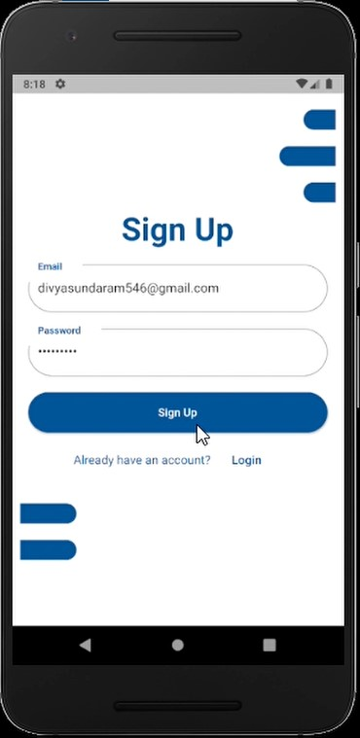

Fig 3 Login Page

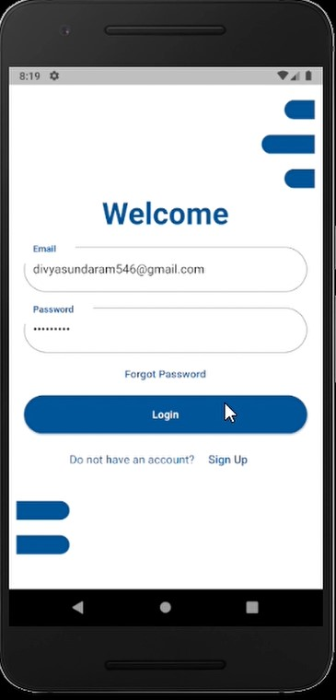

Fig 4 Category Page

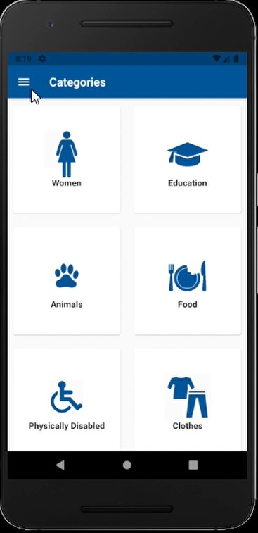

Fig 5 My Donations Page before making Donation

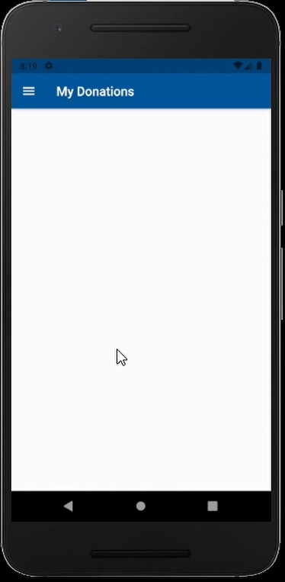

Fig 6 Selecting Clothes Category for Donation

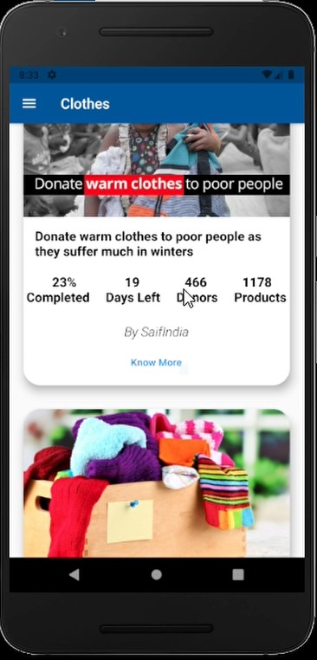

Fig 7.1 Displaying Campaign Details

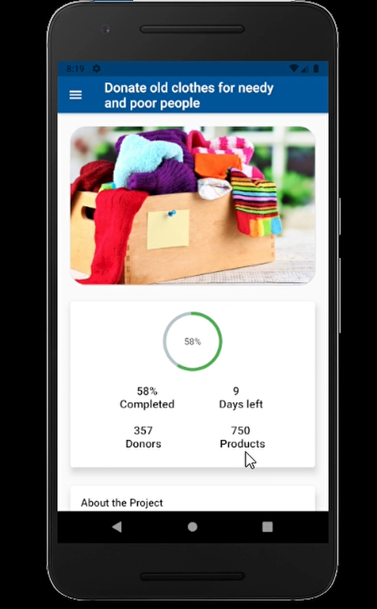

Fig 7.2 Displaying Campaign Details

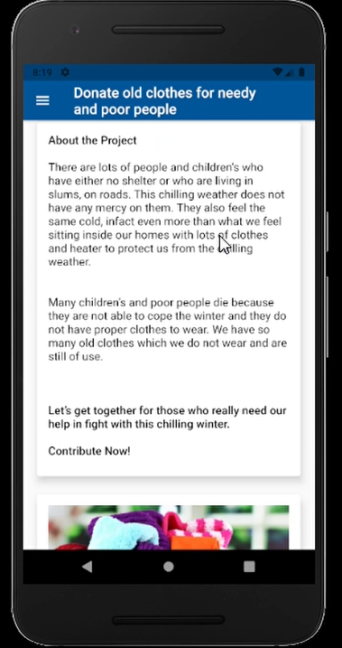

Fig 8 Entering Quantity for Donation

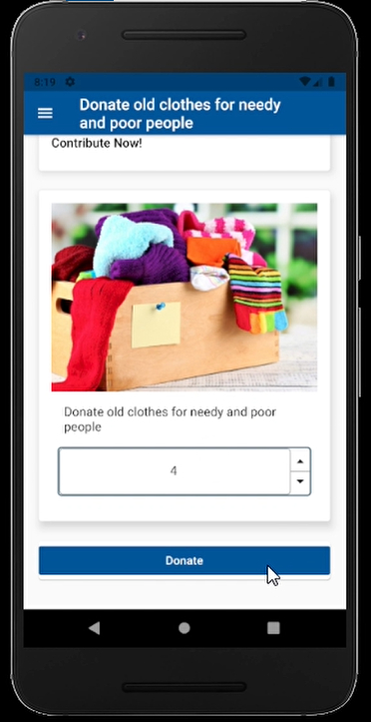

Fig 9 Confirming Donation

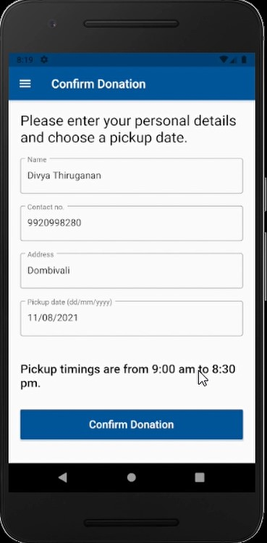

Fig 10 My Donation Screen after Donation

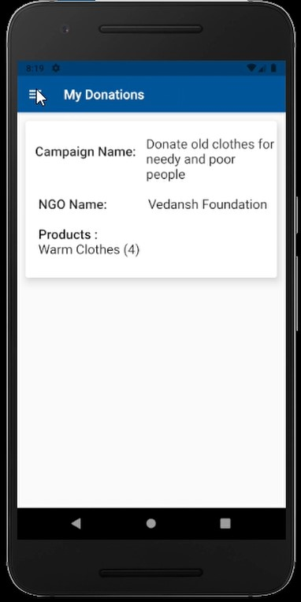

Fig 11 NavBar

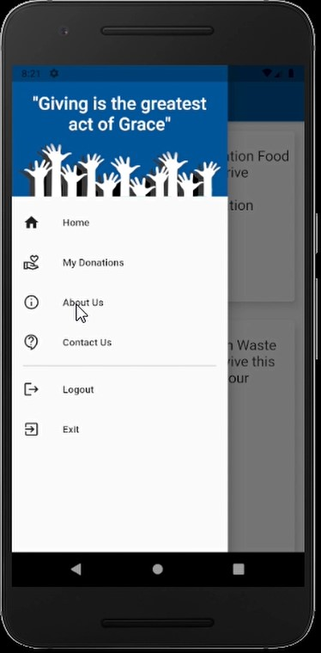

Fig 12.1 About Us Screen

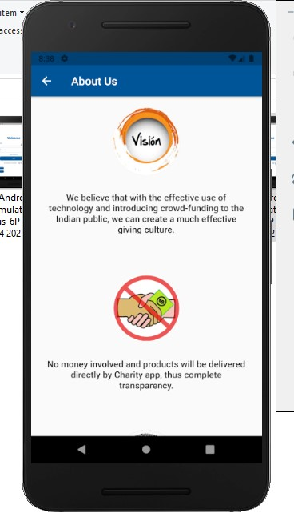

Fig 12.2 About Us Screen

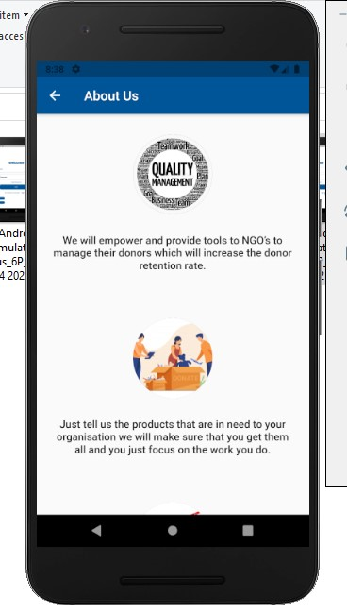

Fig 12.3 About Us Screen

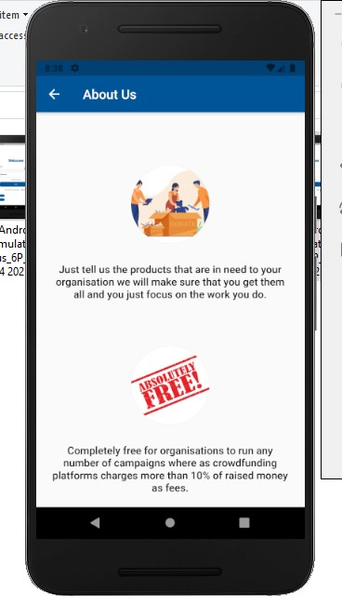

Fig 13 Contact Us Screen

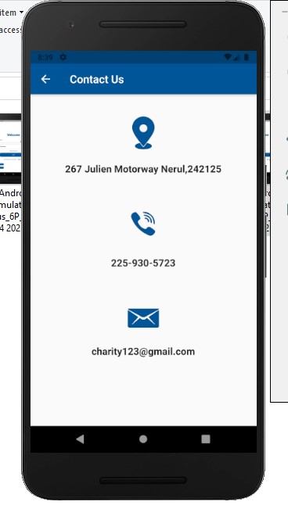

Fig 14.1 Updated Database

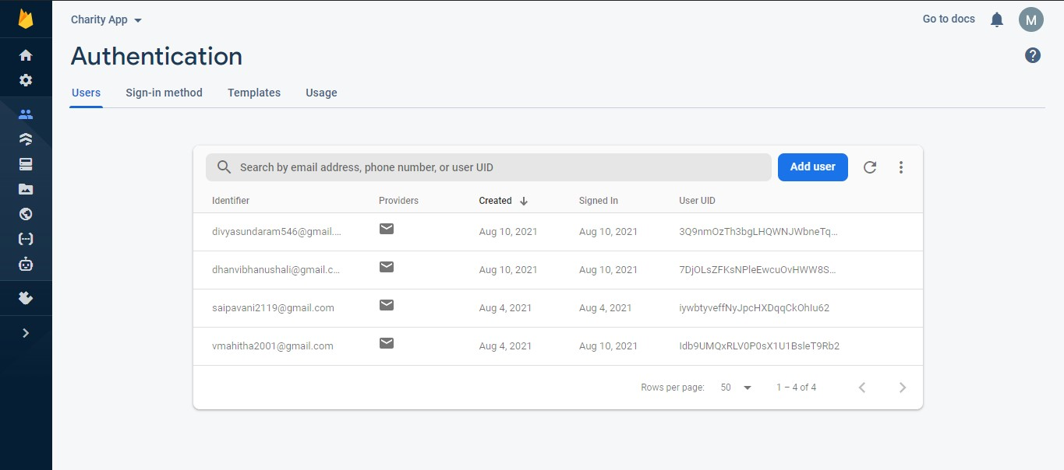

Fig 14.2 Updated Database

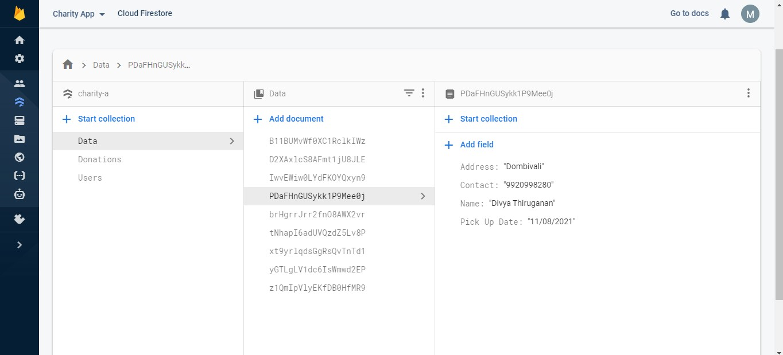

Fig 14.3 Updated Database

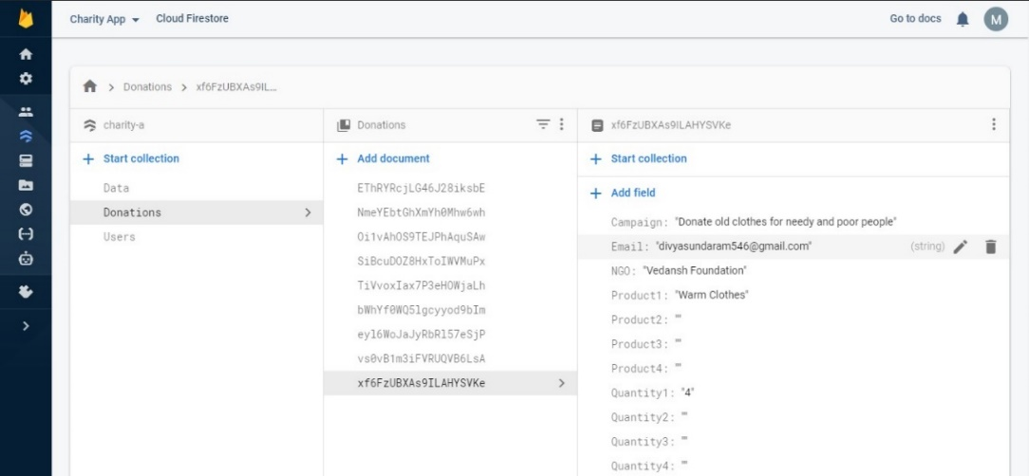

**FUTURE SCOPE**

1. Once a donation is made, we will send an email to the donor which will include the various details of their donations
2. We can provide a section for the users to provide their Feedback for our Services.

**CONCLUSION**

In conclusion, charity is meant for the general betterment of society. The allocation of donations must be strictly monitored to ensure that it does not end up in the wrong hands. There is much hardship in the world, and it is the fortunate man's inherit duty to help better those who are less fortunate. Our platform helps users to connect with various NGOs and donate common household items to them.

**REFERENCES**

***[I] Dunn, Aknin, & Norton:*** *Spending on others increases happiness more than spending on oneself.*

***[II]Liu & Aaker:***  *Nudging solicitation from amount of money to amount of time increases giving counts.*